PRESS RELEASE

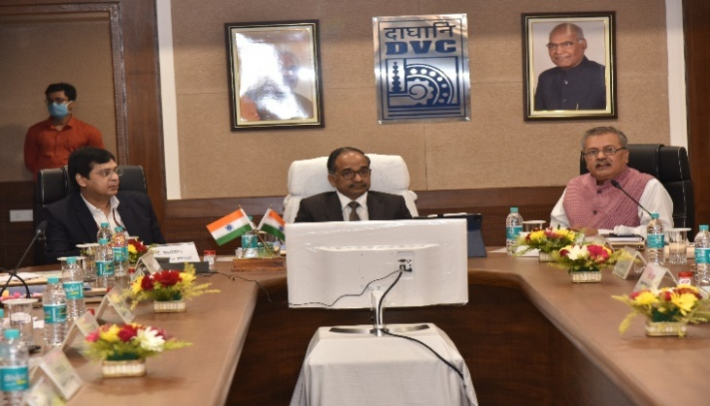

Inauguration of Rooftop Solar PV Project of DVC by the Secretary (Power), GoI
Shri Alok Kumar, Secretary (Power), GOI and Shri A. Upadhyaya, Additional Secretary & Financial Advisor, MOP, GOI visited Damodar Valley Corporation Headquarters, Kolkata on 11.12.2021.
On the occasion of National Energy Conservation Week and Azadi ka Amrit Mahotsav, Secretary (Power) remotely inaugurated Roof Top Solar PV Project (428.5 KWp) of Durgapur Steel TPS, DVC from DVC Hqtrs.

***

