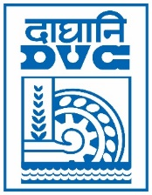 | Damodar Valley Corporation  Information & Public Relations Department  DVC Towers, VIP Road, Kolkata – 700 054  Mobile: 8902242106  E-mail : cpro@dvc.gov.in

PRESS RELEASE

Sub: Consumer Meet organized for DVC retail consumers at Kolkata

A Consumer Meet for retail consumers of West Bengal availing power from DVC was organized at Kolkata on 27th October 2021. During the meet, DVC shared several consumer centric initiatives for ensuring reliability and availability of 24x7 power.

An interactive session was organized where issues of consumers were deliberated upon and constructive discussions was held. The consumers acknowledged the proactive and customer centric approach of DVC. Several consumers were felicitated for their commitment to best practices and compliance of standards.

DVC and consumers jointly resolved for the industrial growth and socio-economic development in West Bengal.

******
27th October 2021
Kolkata

