दामोदर घाटी निगम/Damodar Valley Corporation
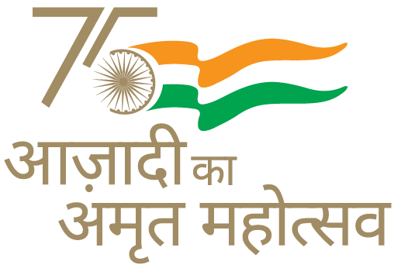
सचिवालय विभाग/Secretariat Department
डीवीसी टावर्स/DVC Towers : वीआईपी रोड/VIP Road
कोलकाता/Kolkata-700054

PRESS RELEASE

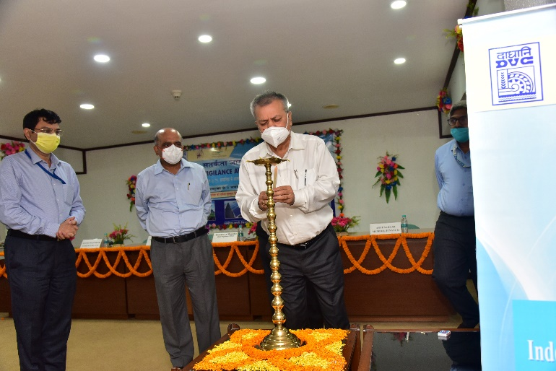

DVC begins observance of VAW-2021

Damodar Valley Corporation (DVC) begins observance of Vigilance of Awareness Week-2021 at its Corporate Office and all projects. VAW 2021 will be observed from 26.10.2021 to 01.11.2021 with the theme “Independent India @ 75 : Self Reliance with Integrity”.
At Hqrs., Kolkata, Chairman DVC administered the oath to the officials and employees present followed by lighting of ceremonial lamp by Chairman, Member-Secretary, Member (Technical), Member (Finance) & Chief Vigilance Officer.
On this occasion Shri Anindo Majumdar, Ex-Secretary, CVC was invited to deliver a lecturer on the topic “Transparency in Governance”.
----------

