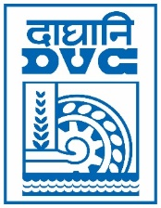 | Damodar Valley Corporation  Information & Public Relations Department  DVC Towers, VIP Road, Kolkata – 700 054  Mobile:8798384207  E-mail : cpro@dvc.gov.in

PRESS RELEASE
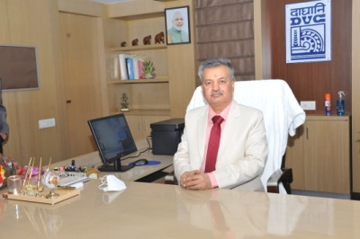

Shri Ram Naresh Singh has assumed the charge of Chairman, DVC from 15th January 2021. Prior to joining DVC, Shri Singh was the Executive Director (Engineering & FQA) at Power Grid Corporation of India Limited. He brings with him more than three decades of rich experience in multifarious areas across the value chain of the Indian power sector.

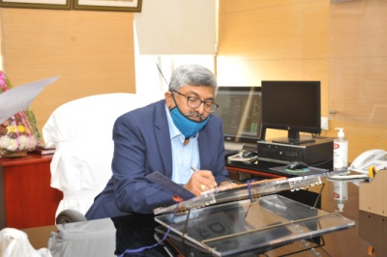
Shri M Raghu Ram has assumed the charge of Member (Technical), DVC from 18th January 2021. Prior to joining DVC, Shri M Raghu Ram was the General Manager (O&M), NTPC Korba. He has more than three decades of experience in Operations & Maintenance and consultancy projects related to the Indian power sector.

******

