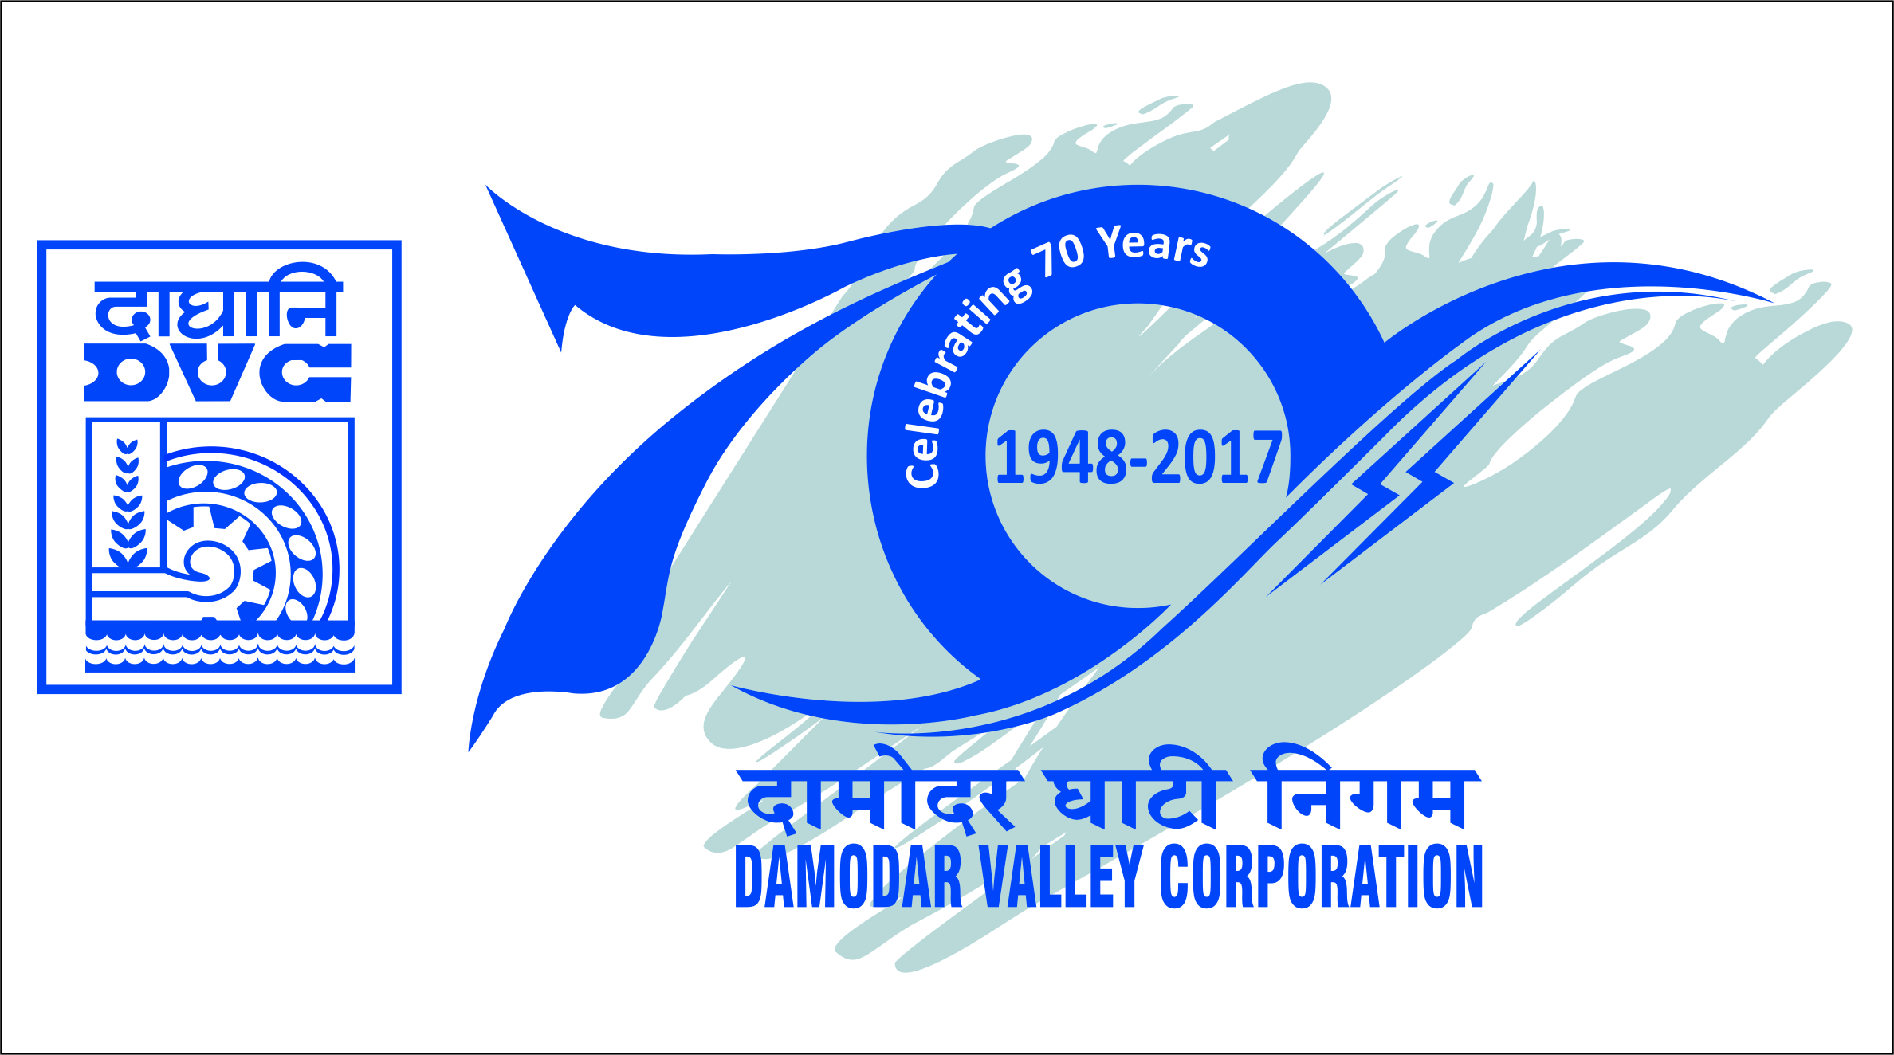

दामोदर घाटी निगम/Damodar Valley Corporation
सचिवालय विभाग/Secretariat Department
डीवीसी टावर्स/DVC Towers : वीआईपी रोड/VIP Road
कोलकाता/Kolkata-700054

PRESS RELEASE

Damodar Valley Corporation (DVC) comes first in NHP rankings

DVC has stood First in the latest rankings of the National Hydrology Project (NHP). The rankings for May 2020 were released by the Ministry of Jal Shakti, Department of Water Resources, River Development & Ganga Rejuvenation, Government of India.

Thirty-Three surface and ground water agencies in the States, Union Territories and river basin organisations were ranked on the basis of assessment of annual rainfall and water flow in rivers, real-time data collection, conduct of training programmes and data digitisation.

The NHP is a 100% Grant-in Aid scheme of Govt. of India with a total allocation of ₹50 crore for DVC. It aims at improving the extent, quality and accessibility of information on water resources; strengthening the capacity of water resources management institutions; and establishing an effective and sound hydrologic database.

Under this project DVC is taking up the works like Real Time Data Acquisition (RTDAS) through Sensors & Satellite Telemetry, Real Time Decision Support System (RTDSS) like Inflow Forecasting & Inundation Modelling through latest software, Sedimentation Survey of all reservoirs, Automation of water drawal by consumers, Water Quality Assessment, Institutional Strengthening etc. for improving the water resources management.

****

