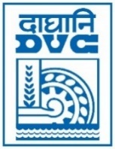 | Damodar Valley Corporation  Information & Public Relations Department  DVC Towers, VIP Road, Kolkata – 700 054  Contact: (033) 6607-2128  E-mail : cpro@dvc.gov.in

PRESS RELEASE

Sub: DVC wins Inter CPSU Chess Tournament, 2022

Team DVC emerged as the Champions in the Men's Team event of 28th Inter CPSU Chess Tournament, held on 20th & 21st September, 2022, at State Convention Centre, Shillong & organised by NERLDC, POSOCO, under the aegis of PSCB, MoP, GoI. There were twelve participating teams from various PSUs of Power sector. Team DVC comprising of Shri Naveen Kumar, Shri Arup Kumar Banerjee, Shri Rajib Lochan Choudhary, Shri Rupesh Kr Mahato & Shri Ajay Satish Topp, remained undefeated in the tournament notching up four victories & a draw.

22nd September, 2022
Kolkata

