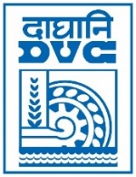 | Damodar Valley Corporation  Information & Public Relations Department  DVC Towers, VIP Road, Kolkata – 700 054  Contact: (033) 6607-2128  E-mail : cpro@dvc.gov.in

PRESS RELEASE
Sub: DVC emerged as the Champions in Team Event of 26th Inter CPSU Bridge Tournament 2022-23
Team Damodar Valley Corporation bagged the Champions’ Trophy in the Team event of the 26th Inter Central Power Sector Undertakings Bridge Tournament 2022-23, organized from 12th -14th January ’23 by DVC under the aegis of Power Sports Control Board, Ministry of Power, GoI. The first and second runner up spots in the Team event were secured by Team THDC India Ltd. and Team Ministry of Power respectively. The Tournament witnessed participation from across 10 utilities of the Indian Power sector. The tournament infused a sense of true sportsmanship and team spirit amongst all the participants.

************

16th January 2023

