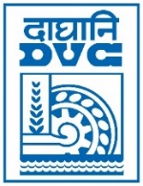 | Damodar Valley Corporation  Information & Public Relations Department  DVC Towers, VIP Road, Kolkata – 700 054  Contact: (033) 6607-2128  E-mail : cpro@dvc.gov.in

Press Release
Sub: DVC received IAC Corporate Awards 2023.
Damodar Valley Corporation has been awarded as the winner of “Pioneering Work in Creating Future- Ready Inclusive Organization” in the Public Sector category of IAC Corporate Awards 2023 by the Industry Academia Conference .
The award was received by the respected Member Secretary, DVC on 17.02.2023 at New Delhi.

************

17th February 2023

