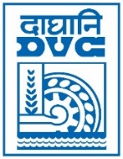 | Damodar Valley Corporation  Information & Public Relations Department  DVC Towers, VIP Road, Kolkata – 700 054  Contact: (033) 6607-2128  E-mail : cpro@dvc.gov.in

Press Release
Sub: Durgapur Steel Thermal Power Plant of DVC sets record by successfully co-firing biomass along with coal to generate power.

Durgapur Steel Thermal Power Plant (2 x 500MW), a Thermal Power Station of DVC situated at Andal, West Bengal has successfully started co-firing of biomass pellets (Non-torrefied) along with coal.
As per policy issued by SAMARTH Mission, Ministry of Power, Government of India, coal fired thermal power stations have obligation of 7% blending of biomass pellets along with coal. This will save coal consumption as well help in achieving carbon neutrality and “ Net Zero” targets.

************

01st March, 2023

