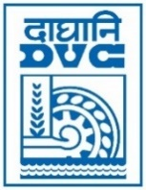 | Damodar Valley Corporation  Information & Public Relations Department  DVC Towers, VIP Road, Kolkata – 700 054  Contact: (033) 6607-2128  E-mail : cpro@dvc.gov.in

PRESS RELEASE

Sub: DVC achieves MOU target for FY 21-22

In continuation with its remarkable upward trend in performance, DVC achieved in advance its MOU target of 41,000MU, set by the Ministry of Power, GoI, for Annual Thermal Power Generation, when it clocked 41,064MU on 15 March, 2023. The thermal power plants of DVC at MTPS, DSTPS & BTPS have also crossed their respective record of highest annual generation, making this FY a landmark in the history of the Corporation.

March 16, 2023
Kolkata

