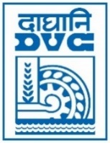 | Damodar Valley Corporation  Information & Public Relations Department  DVC Towers, VIP Road, Kolkata – 700 054  Contact: (033) 6607-2128  E-mail : cpro@dvc.gov.in

PRESS RELEASE

Sub: DVC felicitated with Best Performing Central Public Sector Entity Award in National Workshop on Electronic Procurement, 2023.

Damodar Valley Corporation has been felicitated with an award in the category of “Best Performing Central Public Sector Entities” in the National Workshop on Electronic Procurement jointly organized by National Informatics Centre, Ministry of Electronics & Information Technology, GoI and the Department of Expenditure, Ministry of Finance, GoI on 27.03.2023 at New Delhi. DVC has been selected as the winner for its remarkable performance in the domain of electronic procurement which includes various parameters like Publication of Award of Contract, shortest completion of tender cycle, increase in bids received, use of online payment, least number of corrigendum etc.

March 27, 2023
Kolkata

