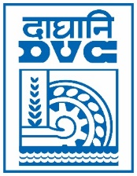 | Damodar Valley Corporation  Information & Public Relations Department  DVC Towers, VIP Road, Kolkata – 700 054  Contact: (033) 6607-2128  E-mail : cpro@dvc.gov.in

PRESS RELEASE

Sub: DVC achieves its highest ever generation in FY 2022-23

Damodar Valley Corporation (DVC) has ended the last FY on a trailblazing note. The organization achieved the highest generation in its 75 year history, by registering 43.326 BU in FY 2022-23, which includes 43.087 BU of Thermal, 239.4 MU of Hydel & 0.11 MU of Solar power. The thermal generation is also the highest ever, surpassing the record of 40.75 BU, set in previous FY. The Plant Load Factor (PLF) stood at 74.23 %, which is the highest in last two decades. Total energy supplied by DVC increased by 2.6 BU marking a 6.5% increase. The Billing & Collection of power sale revenue also showed a marked improvement by a rise of 29% & 23% respectively over the last FY.
DVC plans to implement significant capacity addition in renewable energy in the coming years.
******
1st April, 2023
Kolkata

