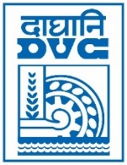 | Damodar Valley Corporation  Information & Public Relations Department  DVC Towers, VIP Road, Kolkata – 700 054  Contact: (033) 6607-2128  E-mail : cpro@dvc.gov.in

PRESS RELEASE
Sub: DVC conferred with the “ Most Innovative Procurement through GeM” award
DVC has been awarded in the category of “Most Innovative Procurement through GeM ” in the recently concluded क्रेता - विक्रेता गौरव सम्मान समारोह 2023 held at New Delhi on 26.06.2023. The award was presented to DVC by Shri Piyush Goyal, the Hon’ble Minister of Textile, Commerce and Industry, Consumer Affairs and Food and Public Distribution, Govt. of India. The Member Technical , DVC – Shri M. Raghu Ram and Executive Director (C&M)—Shri A.K. Dutta received the award.

l************

27th June 2023

