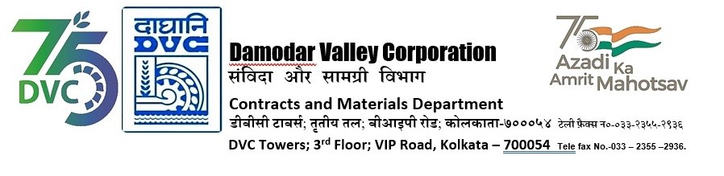

Abridged version of IFB/NIT for SINGLE STAGE THREE ENVELOPE BIDDING

DVC invites online bids on Single Stage Three Envelope Bidding basis in GeM detailed below
---------------------------------------------------------------------------------------------------------------------------------------
Tender ID | DVC/WP/CTPS/C &I U# 7 and 8/00118
Package Name | Proposal for deputation of service engineer of M/S Reineke Engineering Pvt. Ltd on chargeable basis for servicing of hydraulic actuator of Seal Steam (MAW#10) and Leak Steam (MAW#50) pressure control valves of CTPS, Unit#8 by M/s Reineke, the OEM during Overhauling.
*Bidding Document Download  Starts from (Tentative Dates) | 29-04-24
*DVC reserves the right to amend the dates.

For the detailed IFB and bidding documents please visit
https://gem.gov.in
or
DVC Portal from 29.04.2024 onwards or may contact Sr. General Manager, C&M Department,
3
rd
Floor, DVC Towers, VIP Road, Kolkata, West Bengal, India, PIN – 700054.

Mobile No. +91 9749480765
Email ID:
nyayapati.ramana@dvc.gov.in

Registered office:
DVC Towers
VIP Road, Kolkata
West Bengal, India
PIN – 700054

