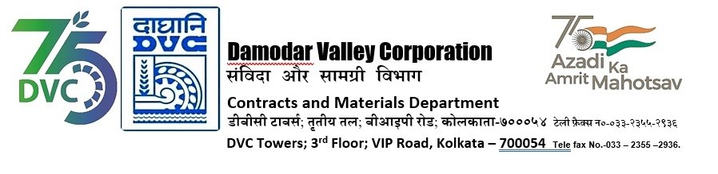

Abridged version of IFB/NIT for SINGLE STAGE THREE ENVELOPE BIDDING

DVC invites online bids on Single Stage Three Envelope Bidding basis in GeM detailed below
---------------------------------------------------------------------------------------------------------------------------------------
Tender ID | DVC/WP/CTPS/C &I U# 7 and 8/00116
Package Name | verification and health checking of Bently-Nevada make Turbine differential expansion, Axial Shift and VMS system Of Turbine Shaft and Bearing Vibration, Generator Shaft and Bearing Vibration and all HT drives Bearing Vibration, Keyphasors including CW pump Bearing Vibration,Keyphasors along with software related problem of whole system including vibration monitoring System Server/ computer of the unit of CTPS U#8 by M/S GE Oil & Gas India Private Limited, The OEM during the AOH of unit #8.
*Bidding Document Download  Starts from (Tentative Dates) | 22-04-24
*DVC reserves the right to amend the dates.

For the detailed IFB and bidding documents please visit
https://gem.gov.in
or
DVC Portal from 22.04.2024 onwards or may contact Sr. General Manager, C&M Department,
3
rd
Floor, DVC Towers, VIP Road, Kolkata, West Bengal, India, PIN – 700054.

Mobile No. +91 9749480765
Email ID:
nyayapati.ramana@dvc.gov.in

Registered office:
DVC Towers
VIP Road, Kolkata
West Bengal, India
PIN – 700054

